PERSISTENT SYSTEMS LIMITED

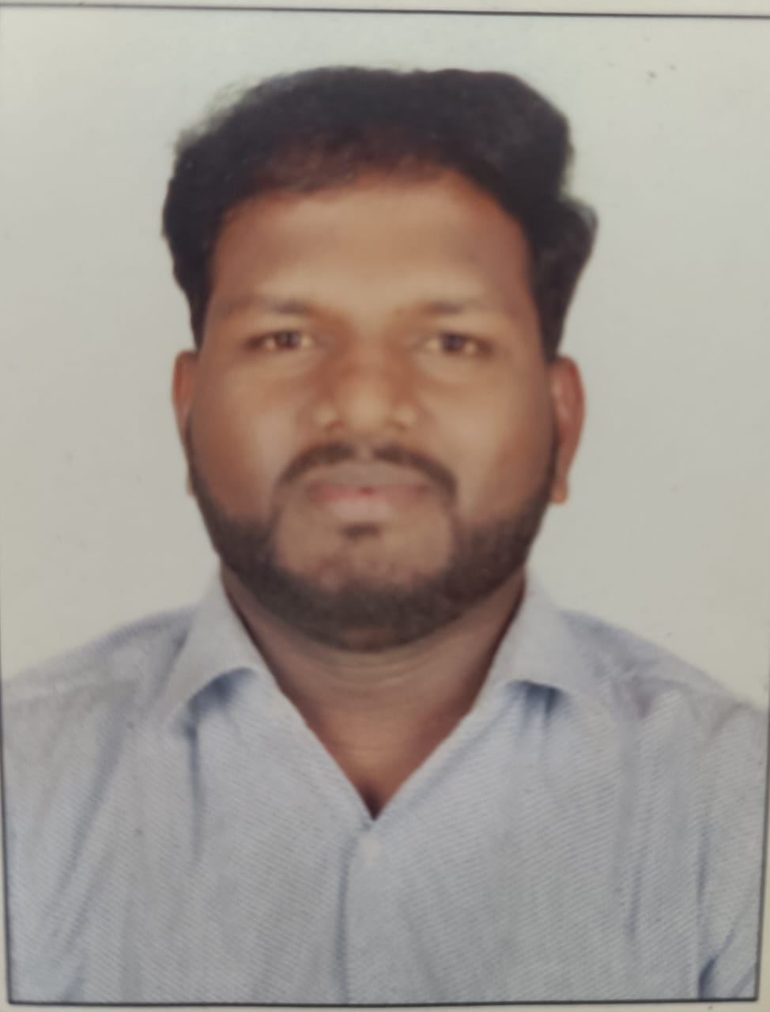
Photograph


Personal Information Form

A. Applicant Details

Name (as in the Aadhar card) | First name: Rajendra |  |  | Middle name: Namdev |  |  |  |  | Last name: Lokhande
Current address (If different than permanent address) | Flat no 202 Shiv Appartment Near Ashapushpa School, Abhinav Collage Road Narhe -411041
Current address (If different than permanent address) | Tel. No.: Mobile No.:9272129044
Permanent address | At- Khilarwadi, Po-Vajrawad, Tel-Jath, Dist-Sangli - 416404
Permanent address | Tel. No.: Mobile No.:
Email ID | rajendralokhande200@gmail.com
Citizenship (Passport Issuing country)
Country of Birth: | Indian
Date of birth (dd-mm-yyyy) | 07/05/1989
Marital status | Married
Gender | Male
Are you under any Service Agreement? | No
Do you know anyone working with Persistent? | No
Have you been interviewed at Persistent in the last 6 months? | No  Date:
Languages known (underline mother tongue) | Language |  | Read |  | Write |  | Speak |  |  | Proficiency if any
Languages known (underline mother tongue) | English |  | Yes |  | Yes |  | Yes
Languages known (underline mother tongue) | Hindi |  | Yes |  | Yes |  | Yes
Are you suffering/have you suffered from any critical illness | No |  | If yes, give details
Have you been convicted / involved in any criminal litigation? | NO
Are you Willing to shift to related technologies as per business needs ? |  |  |  |  |  |  |  | Not Sure

Passport Details - Do you have a valid passport? No

Details of Family Members (Parents / Siblings / Spouse / Children)

Sr. No | Name | Relationship | Age | Occupation
1 | Namdev Bhanu Lokhande | Father | 66 | Farmer
2 | Janabai Namdev Lokhande | Mother | 56 | House wife
3 | Dhanashri Rajendra Lokhande | Spouse | 28 | service
4

B. Educational Details (From Highest Qualification)

Sr. No. | Educational Qualification | Year of passing | Percentage | University /Institute | State/ /Country
1 | High School | 2006 | 37 | Kolhapur Board | Maharashtra
2 | Higher Secondary School | 2009 | 67 | Kolhapur Board | Maharashtra
3 | B.Com | 2012 | 57 | Kolhapur University | Maharashtra
4 | MBA | 2014 | 57.13 | Savitrribai Phule Pune University | Maharashtra

Other Courses / Additional Qualification / Awards / Certifications

Sr. No. | Title of the course / program / qualification / award | Institute / University | Part Time/ Full Time | Duration & Year of passing

Skills

Skills | Primary / Core Skills | Secondary Skills | Domain Expertise
Java | Java, Java 8, ,Spring boot Microservice, JPA, | Mysql,postgress,Redis,Rabbit mq | Logistic, Insurance
UI |  | Html,java script
Cloud

C. Employment History

Give details of the Employment (Latest first)

Sr. No. | Company Name and Tel.No. | Start  MM-YYYY | End  MM-YYYY | Last Position Held | Role / Nature of Duties | Software tools used | Last Salary drawn | Reasons for leaving
1 | Bajaj Allianz Life Insurance | 01-2019 | 11-2020 | Associated RM | Development | Java | 2.75L | Carrer growth
2 | Tata Aia Life Insurance | 04-2021 | 10-2023 | Sr. CRM | Development | Java, Java8, Spring Boot, Eclips | 5L | Career Growth
3 | Advanced Infoscan Pvt ltd | 11-2023 | 10-2024 | Software Engineer | Development | Java, Spring boot, Microservices, | 7L | R Relocate for Pune
 |  |  |  |  |  |  |  | S

D. Compensation

Please give details of your current salary. Please attach Photocopy of your last two months pay slip

Salary Head | Per Month (Rs.) | Per Annum (Rs.)
7Lpa |  | 7 lpa
Total

Expected salary per month: 14.5 lpa

Notice period required in current Job

Normal notice period: 30 days Earliest date you can join: 10 Oct 2024 (Negotiable)

Professional References who can be contacted (Give names of people other than your relatives) | Name | Contact details(Phone #,address) | Period from when known | Capacity in which he/she knows you
Voya India Pvt ltd | Pratik Mohite | 8888689996 | 3 year | Friend
Infogain pvt ltd | Akshay Kanade | 9970422875 | 5 year | Friend

Specify your career achievements :

Comments by Applicant (if any): Looking For Pune location

DECLARATION

I, the undersigned, hereby declare that all the above information is valid & accurate to the best of my knowledge. I understand and fully agree that any information provided by me herein which is found to be erroneous or otherwise incorrect, which tend to mislead the Company will be sufficient cause for the Company to terminate my services from the Company at any time during my employment. I authorize the Company to carry out my reference / background check.

Date: 09-10-2022 Rajendra
(Signature of the Applicant)
Place: Pune

